IRIS Species Dataset Summary

1.Plot distribution of numerical features (Histograms)
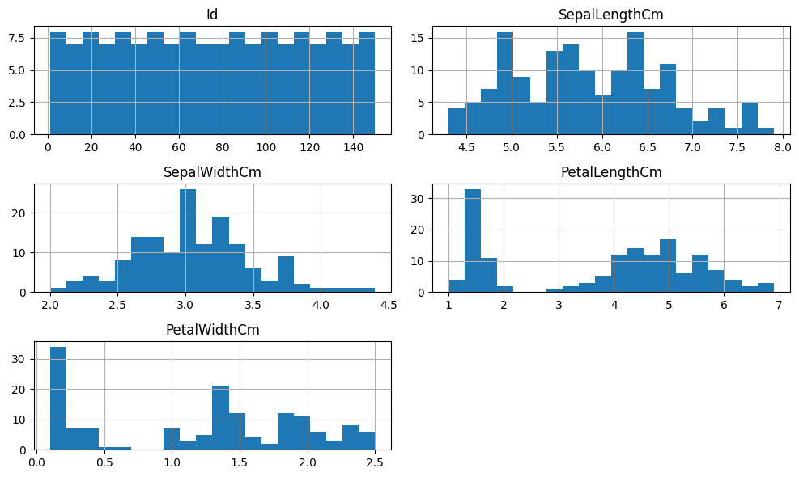

Insights:
- Features follow *near-normal distributions*
- Petal features show *better class separation*
- No extreme skewness observed

2.Analyze categorical features (Count Plot)
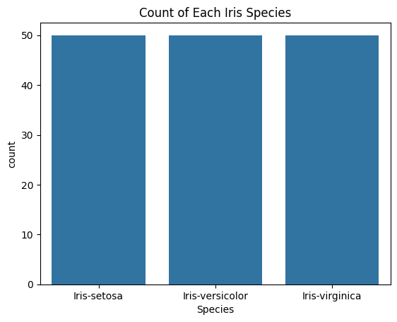
Insights:
- Dataset is *balanced*
- Each species has equal number of samples
- No class imbalance issue

3.Box plots to identify outliers
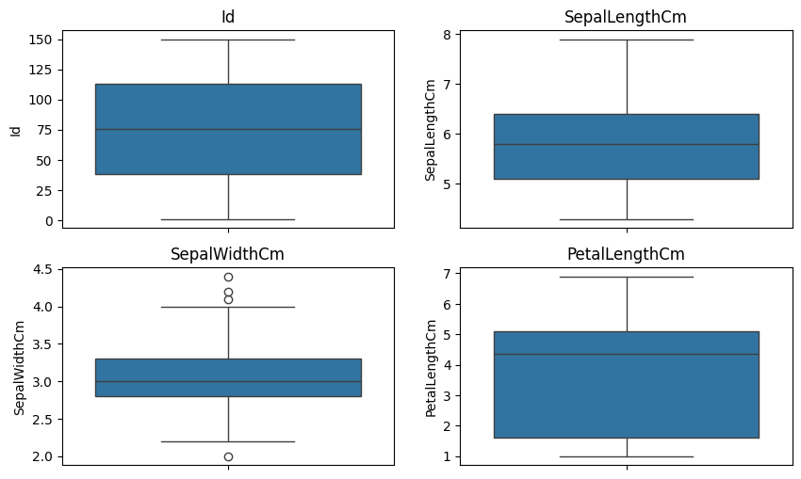
Insights:
- Minor outliers present in *sepal width*
- Petal features have *clean distributions*
- No need for outlier removal

4. Correlation heatmap

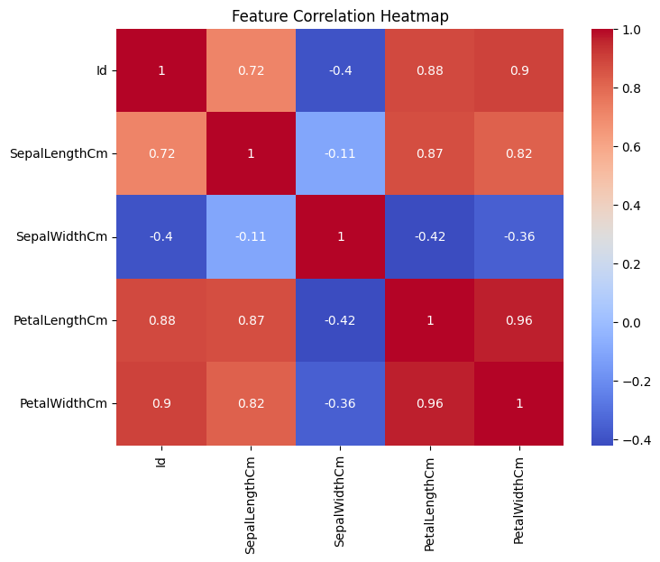
Insights:
- Strong correlation between *petal length & petal width*
- Sepal features are weakly correlated
- Multicollinearity minimal

5. Feature importance using correlation with target

Petal Width Cm | 0.956464
PetalLengthCm | 0.949043
Id | 0.942830
Sepal Length Cm | 0.782561
Sepal Width Cm | -0.419446
dtype: float64

- Petal width has *highest correlation*
- Petal length is second most important
- Sepal width contributes least

6. Key Predictive Features:

- Petal Width
- Petal Length
- Sepal Length

Summary:

- Dataset is *clean and balanced*
- No major missing values or extreme outliers
- *Petal features* are strongest predictors
- Strong correlation between petal dimensions
- Suitable for *classification models* like Logistic Regression, SVM, Decision Tree

